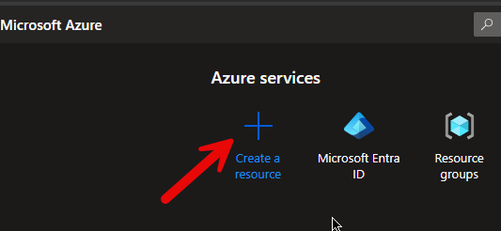

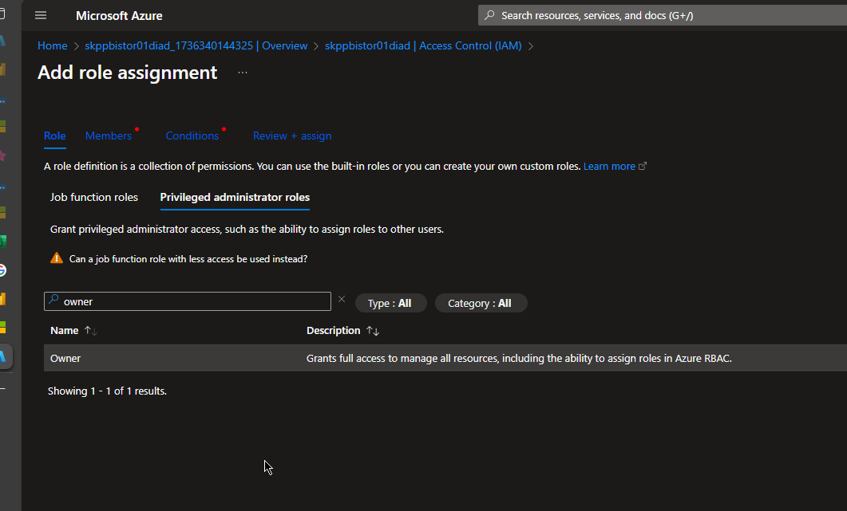

The user that creates the connection must be assigned “Owner” on the storage account and the resource group.



The applicaion ”Power BI Service” must be assigned “Reader” role on the storage account.

